**Coding Standards**

* Coding Standards in Magento 2 are rules that everyone follows when writing code in Magento 2
* The rules it helps to look the code same and well for everyone
* It includes how to name files and functions where to put different parts of code
* How to write comments to expand the codes.
* This coding standards helps us to easy to read the code,understand,work with this and specially when the many people working in the same project.
* It's like having shared language that all the developers speak when they are working in Magento Websites.

**Advantages:**

1. **Clear Code**: Coding standards make the code easy to understand for everyone working on it.
2. **Easier Collaboration**: When everyone follows the same rules, it's simpler for different developers to work together without confusion.
3. **Less Mistakes**: Following standards helps catch errors early and prevents common coding mistakes.
4. **Faster Maintenance**: Well-organized code is quicker to update and fix, saving time in the long run.
5. **Safer Websites**: Coding standards include security best practices, making Magento websites less vulnerable to attacks.

**Disadvantages:**

6. **Learning Curve**: It takes time for developers to get used to the rules, which can slow down initial progress.

7.**Feeling Restricted**: Some developers might feel constrained by the rules and find them limiting.

8. **Extra Work**: Enforcing standards means extra effort in setting up tools and processes.

9.**Different Opinions**: People might disagree on the "right" way to write code, leading to conflicts.

10.**Potential Confusion**: Sometimes, too many rules can be overwhelming and cause confusion, especially for newcomers.

**PHP storm:**

* PHP Storm is an integrated development environment (IDE) Specially designed for PHP development
* It helps the developers by highlighting the errors in the code, debugging tools, version control and support for various php frameworks like Magento.

**How coding standards connects PHP storm:**

* PHPStorm is an IDE that provides powerful tools for Magento 2 Development, including built-in support for coding standards.
* Developers can configure PHPStorm to automatically check their code against Magento 2 Coding Standards.
* Check their code against Magento 2 coding standards as they we write it. This helps developers identify and fix coding standard violations in real-time, ensuring that the code remains consistent and compliant with Magento 2 Standards.

**Advantages of PHP Storm:**

* **Easy to Use**: PHPStorm is simple and easy for all developers.
* **Helpful Tools**: It helps you write code faster and with fewer mistakes.
* **Works with Git**: It works well with Git, a popular tool for managing code.
* **Good for Magento 2**: It's great for working on Magento 2 projects.
* **Can Be Changed**: You can make it look and work how you want.

**Disadvantages of PHP Storm**

* **Needs Power**: It might need a lot of computer power, especially on older computers.
* **Not Free**: You must pay for it after a trial period.
* **Takes Time to Learn**: It can take time to get used to it, especially if you're new to this kind of tool.
* **Lots of Stuff**: It has many features, which might be too much for some people.
* **Works Differently on Different Computers**: It might not work the same on all types of computers.

**How to Install PHP storm**

* Go to <https://www.jetbrains.com/>
* Click ->Developers tools->phpstorm
* Download
* The file in be in the downloads folder
* Go to Terminal
* Navigate to downloads folder
* Cd downloads
* To extract the content, we downloaded

tar –xvf PhpStorm-2024.1.tar.gz

* Command line ls –lh
* Create a new bin folder
* Launch php storm

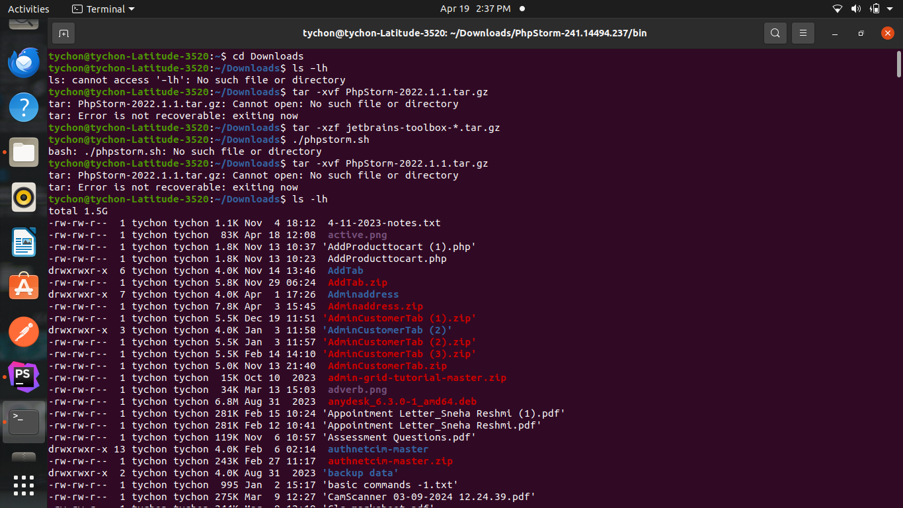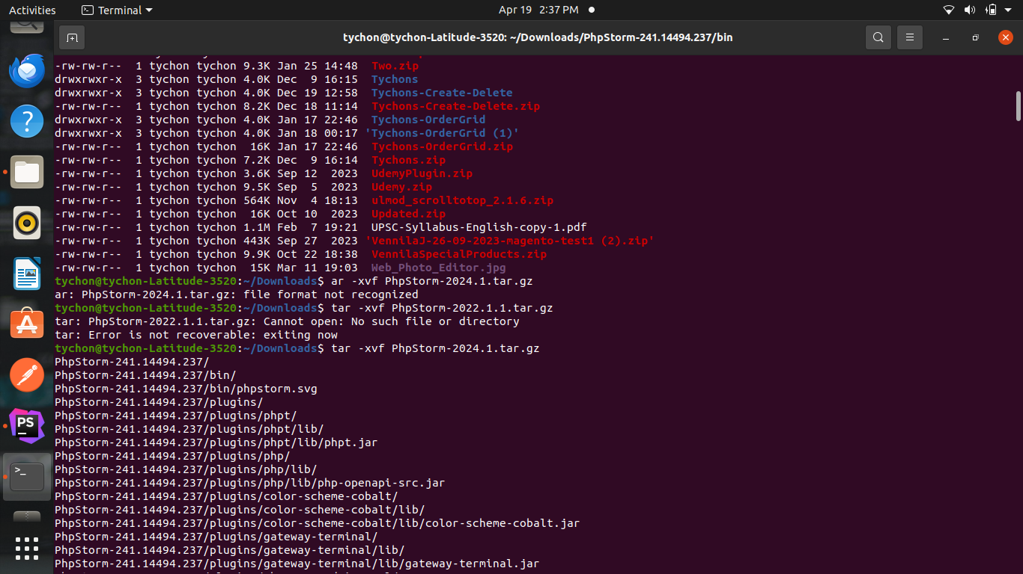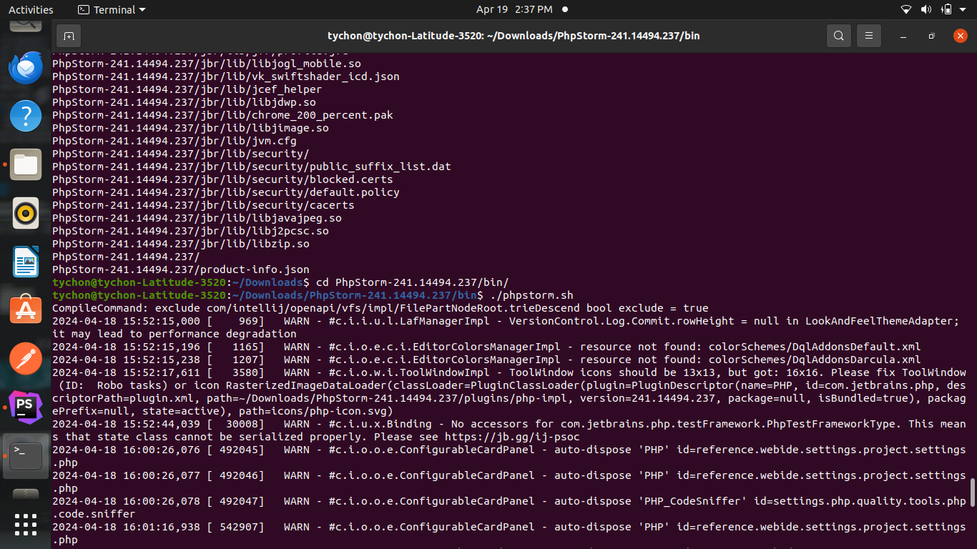

**Setup:**

* Open phpstorm ->settings
* Quality tools->php code sniffer

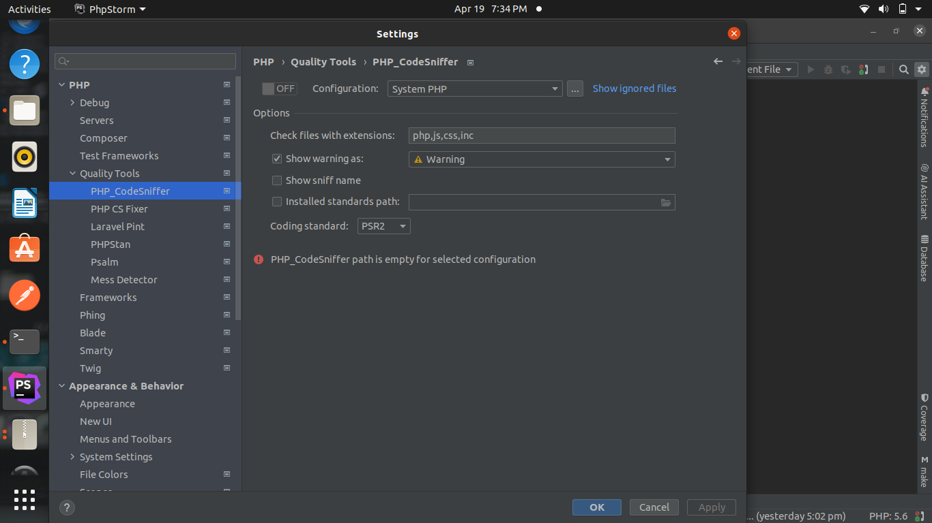

* Switch on the button and add the path requires
* For standard path
* /var/www/html/magento246/vendor/phpcompatibility/php-compatibility/PHPCompatibility

Final output:

